Purpura Reunion 2025
Date: Friday July 25, 2025 to Sunday, July 27, 2025
Dates were selected based on responses from family members and condo and hotel availability.

Lodging
After researching several Lake Tahoe housing options and an in-person visit by Fred and Mary Glasser, three hotel/condo locations were chosen. These are: Beach Retreat & Lodge Tahoe (Property 1), Tahoe Lakeshore Lodge & Spa (Property 2), and Lakeland Village (Property 3). Because these properties are all located within walking distance of each other on the beach side of South Lake Tahoe, each family can select what best suits their needs. Also, there is a campground very close by. If you prefer to camp, you can easily join up with family members staying at one of the other three locations to enjoy the beach hotel/condo amenities.
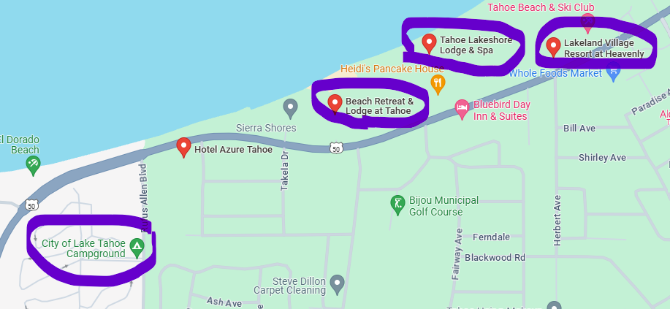

Note: If you recall years ago, the reunion was held at the Lakeland Village listed below. This property no longer has a common area to host a large party, like the Beach Retreat & Lodge Tahoe. Also, Lakeland Village no longer has hotel options available, it is strictly condos, managed by a Company name Vacasa. If desiring a larger space, to accommodate your family size, this may be the best option for your group. More information below on booking through Vacasa for Lakeland Village.

Details of Each Property:

(Property 1) – Beach Retreat & Lodge Tahoe. Contact is Director of Sales is Brittany Gregonis bgregonis@tahoebeachretreat.com

Set on the south shore of Lake Tahoe, this laid-back resort is 2 miles from both Harrah's Lake Tahoe casino and Heavenly Mountain Resort. The cozy, casual quarters come with gas fireplaces and coffeemakers, plus iPod docks, flat-screen TVs and complimentary Wi-Fi. Most rooms have balconies or patios, while some add lake views and direct beach access. Amenities include a heated outdoor pool, as well as a pier and a marina with jet ski and kayak rentals. There are two restaurants and a tiki bar, a meeting/event space, and laundry facilities. Parking is free. Also, it is dog friendly.

Please click on the following link for more information on the Beach Retreat and Lodge: https://www.tahoebeachretreat.com/

Note: We received a contract for the event space and Brittany has reserved a block of rooms at a special rate. See proposal at the link below:

Purpura Family Reunion - Beach Retreat & Lodge at Tahoe (proposalpath.com)
Included within the proposal:
- A list of our available room types and group rates for each. Please note that they do not have enough Beachfront options to accommodate our entire group.
- The meeting space with room rental and food & beverage details for dinner.
- A link to their catering menu.
- Links to other activities to do in South Lake Tahoe

We will be signing a proposal which includes a $3,000 deposit for reservation of the meeting room for dinner, which is applied towards a required $7,500 Food and Beverage Minimum. This deposit is being initially paid for by Terry Purpura and will be reimbursed by attending families later. Brittany Gregonis will create a group code for our family to be used on their website or over the phone for discounted rates. At the time of booking, they ask for a credit card on file and will process a deposit of the first night’s room/tax total. On the morning of arrival, they will process the remaining balance due. If a family member needs to cancel, they can do so up to 72 hours prior to arrival and they will receive their deposit back.

(Property 2) – Tahoe Lakeshore Lodge & Spa. Contact is Lisa Gallup, Director of Sales & Marketing, 530-541-2180. This property offers a limited number of condos, but they are only available the last week in July and not in August.

A hotel/condo mix, this modern lodge is set on its own private lakeshore beach and is 2 miles from the Heavenly Mountain ski area. It is 2 blocks from Lake Tahoe Boulevard, with its many restaurants and shops; the Nevada casinos are 2 miles away. Offering rustic pine furnishings, all rooms have balconies or patios with lake views, as well as gas fireplaces, coffeemakers, flat-screen TVs, DVD players and free Wi-Fi. Some have kitchens. Amenities are shared with condo owners, and the property offers a heated pool, a hot tub, and a day spa.

A few other notes: It is not dog friendly, there is no A/C, and there are no meeting/business centers to host a family indoor event.

Please note, if desiring to stay at a property 2, Weekends require a 4-night minimum stay for both the hotel and condo options. Our family has been offered a 15% discount on hotel rooms and condos. Pricing varies based on the type of room desired.

The room options and rates are the following: Lodge Queen Hotel Room: 10 rooms at $330.65 per night; Deluxe Queen room: 2 rooms at $339.15 per night; Lodge Queen Hotel Room with Kitchen: 2 rooms at $347.65 per night; Corner View Kitchen Suite Queen Room: 3 rooms at $364.65 per night; Lodge Double Queen Hotel Room: 6 rooms at $339.15 per night; Lodge Double Queen Hotel Room with Kitchen: 3 rooms at $364.65 per night; Corner View Kitchen Suite Two Queen Beds: 1 room at $381.65 per night.
Please click on the following link for descriptions on each room type option: https://www.tahoelakeshorelodge.com/lodge-rooms/

The condo options and rates are the following: One Bedroom Condominium – Lakeview and Lakefront: 4 available at $432.65 per night; One Bedroom Condominium with Loft – Lakeview and Lakefront: 1 lake view at $475.15 per night, 1 lakefront at $509.15 per night; Two Bedroom Two Bathroom Condominium – Lakeview: 3 available at $517.65 per night.
Please click on the following link for descriptions on each condo type:
https://www.tahoelakeshorelodge.com/condominiums/

(Property 3) Lakeland Village. Booking is done through www.vacasa.com. For any assistance, please call: 1-530-544-1685, option #2 for group sales and request to speak with Jonathan, the sales representative of Lakeland Village. He has worked with us up to this point. However, it has been difficult to get help on the phone, and some of the negative reviews for Lakeland Village mention that reaching Vacasa for issues was difficult. Please keep this in mind before booking.

Set on a 19-acre site on Lake Tahoe, this upscale condo resort is 1.2 miles from South Lake Tahoe and 1.6 miles from Heavenly Mountain Resort. The rustic, homey rooms, suites and townhouses have kitchens and flat-screen TVs, plus fireplaces and balconies. Some have vaulted ceilings and lake views. A resort fee provides Wi-Fi, and local shuttle service. There are 2 lakefront pools and hot tubs, along with a sauna and a fitness center. Other amenities include a private mile-long beach with a pier.

A note: while the Lakeland Village website lists that there are “business and meeting rooms,” when we visited, we saw that they are not sufficient areas to host a party and are more akin to office spaces.

To complete a booking for Lakeland Village, you will need to click on the following provided below. Please make sure to select the correct date of 7/25 – 7/27/2025.

Lakeland Village - South Lake Tahoe Vacation Rentals by Vacasa

Currently, there are 109 rental options available for the dates of Jul 25 – 27, 2025. A payment of 50% is due upon booking, if renting 45 days out.

Below is a screen shot from the Lakeland Village - South Lake Tahoe Vacation Rentals webpage that shows two rental options and the total costs before taxes. You can use the dropdown arrow to see the breakdown of the rental costs and fees.

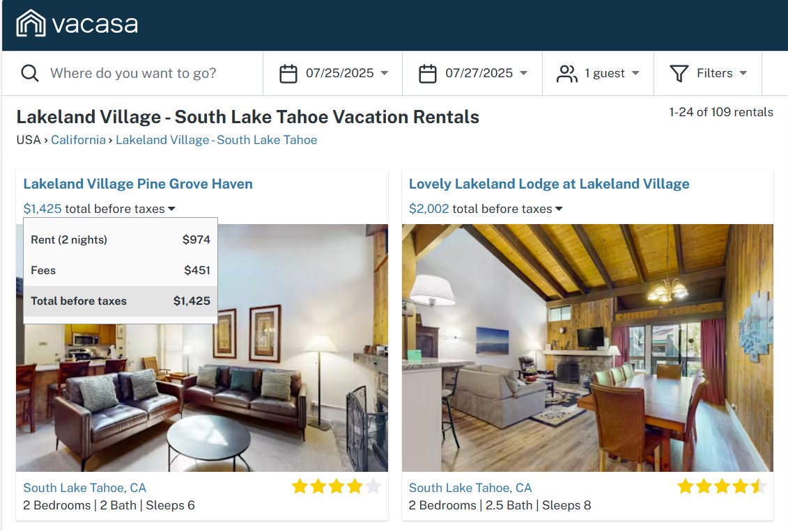

Other Nearby Locations of Interest in South Lake Tahoe:

- Safeway - across the street from Beach Retreat and Lodge
- CVS – next door to Beach Retreat and Lodge and Tahoe Lakeshore Lodge and Spa
- Whole Foods Market - across the street from the Lakeland village
- Many restaurant options within walking distance of all properties
- St. Theresa's Catholic Church – approximately 1 mile from hotel options
- Action Watersports at Timber Cove Marina – in between Beach Retreat and Lodge and Tahoe Lakeshore Lodge and Spa
- Tahoe Bowl – 0.3 miles from Beach Retreat and Lodge
- Bijou Municipal Golf Course – 0.2 miles from Beach Retreat and Lodge
- Bijou Community Park – approximately 1.6 miles from hotel options

